

**Faculty of Engineering and Computer Science**  
 **Department of Mechanical, Aerospace and Industrial Engineering**

AERO 455: CFD for Aerospace Applications

Laboratory 2

Presented to:

Dr. Ziad Boutanios

|  |  |
| --- | --- |
| Gonzalo Noriega Argandona | 40097406 |
| Ahmed Zayed | 40094322 |
| Cole Kennedy | 40095681 |
| Christian Rowsell | 40092183 |
| Rayanrao Kaniah | 40101741 |

Submitted:

March 23rd, 2022

**INTRODUCTION**

The goal of the lab was to become familiarized with using the STAR CCM+ software interface. The lab presented through the STAR CCM+ tutorial file demonstrates how to create a polyhedral 3D computational mesh around a blunt body and how to set up a transonic flow simulation. It is also important to note that the physics modelling parameters as well as the air material properties were altered from those indicated in the tutorial file. The simulation parameters explored were that of the effect of the prismatic cell layer on the turbulence y+ parameter. The parallel efficiency of the solver for each of two different mesh sizes was also studied during the lab.

**RESULTS**

## **2.Solution set-up and Initial run**

**Elapsed time 98.532 s**

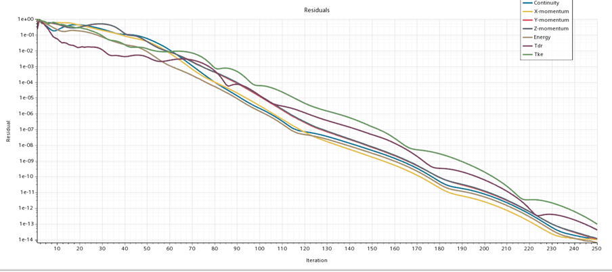

Figure 1: Residual Plot

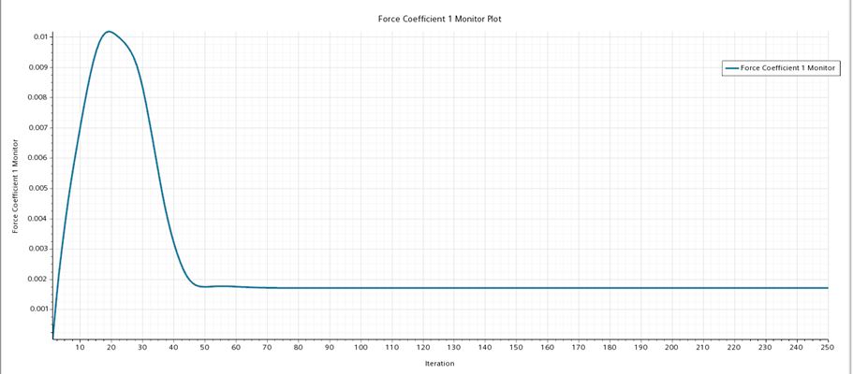

Figure 2: Force Coefficient

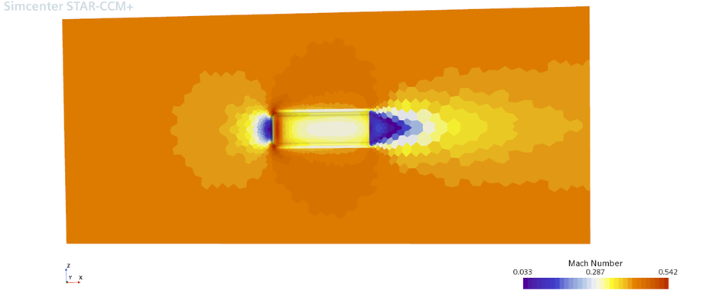

Figure 3: Scalar Scene 1 (Mach Number)

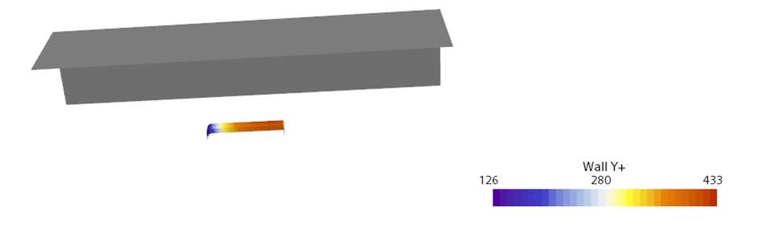

Figure 4: Scalar Scene 2 (Y+)

## **3.Prismatic Layer sensitivity**

### Prism layer 3

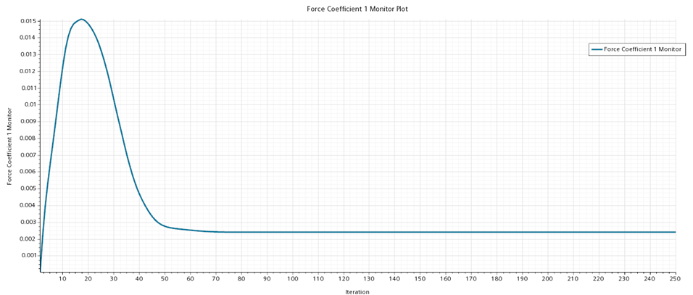

Figure 5: Force Coefficient Plot

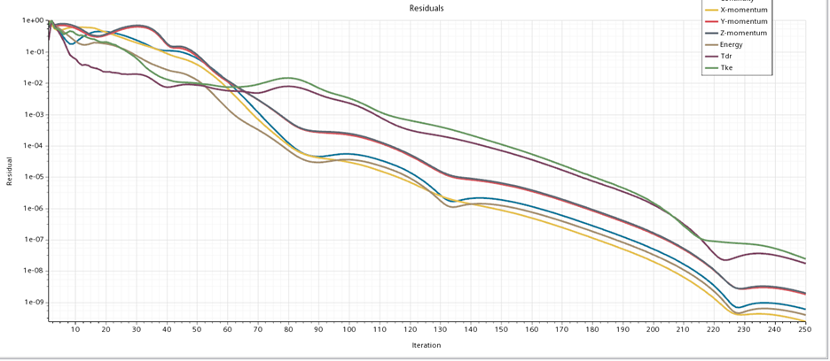

Figure 6: Residual Plot



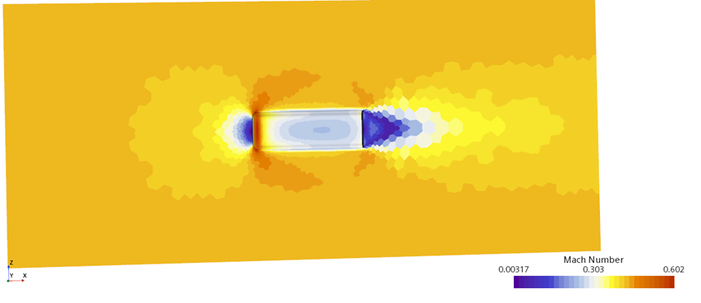

Figure 7: Scalar Scene 1 (Mach Number)

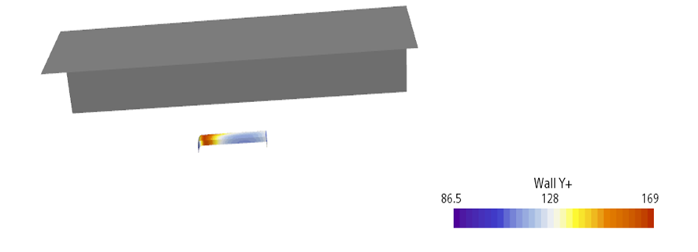

Figure 8: Scalar Scene 2 (Y+)

### Prismatic layer 5

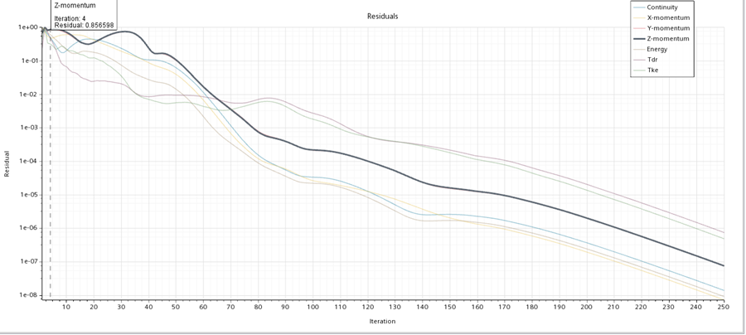

Figure 9: Scalar Plot

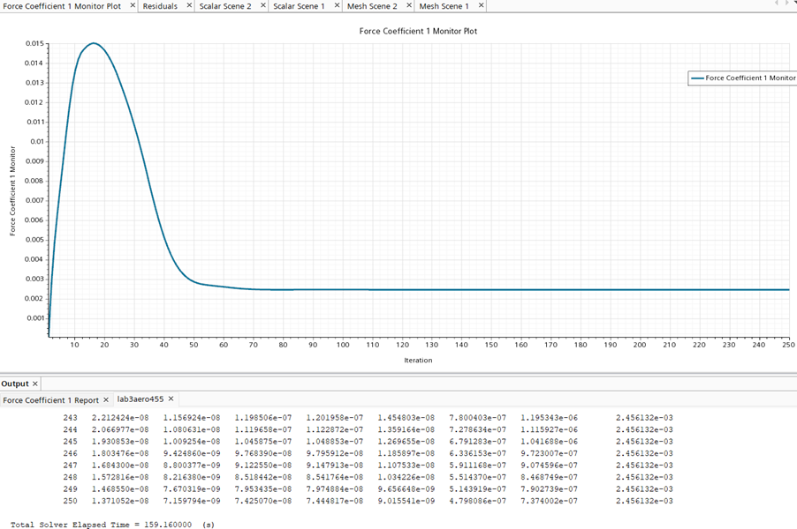

Figure 10: Force Coefficient Plot

Total elapsed time 159.1600s

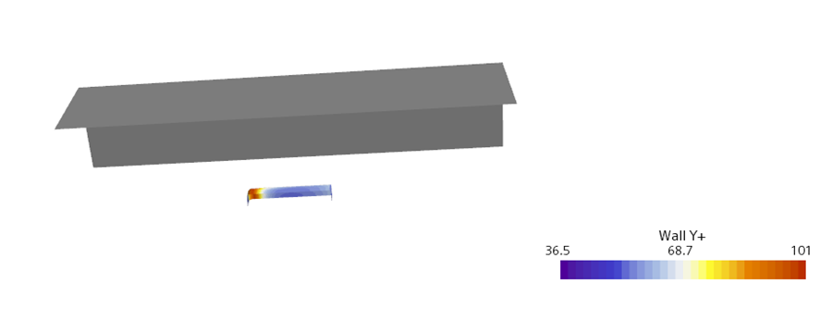

Figure 11: Scalar Scene 2 (Y+)

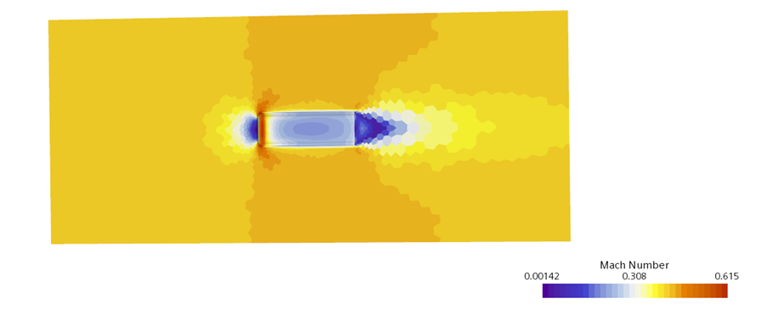

Figure 12: Scalar Scene 1 (Mach Number

### Prismatic layer 6

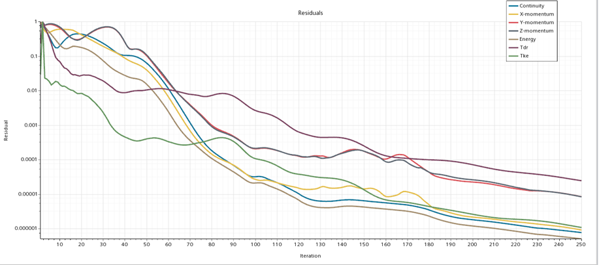

Figure 13: Residual Plot

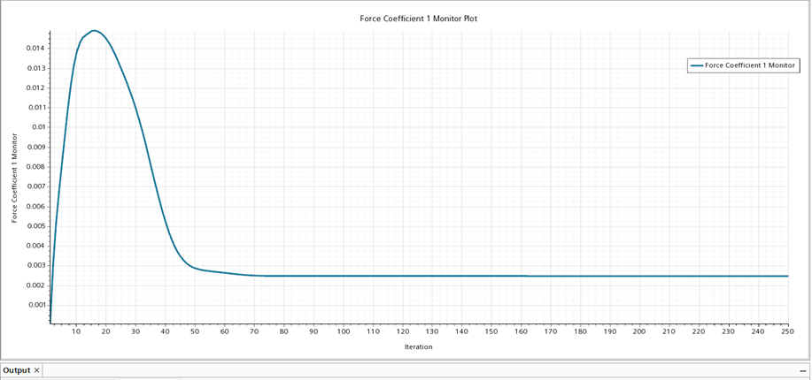

Figure 14: Force Coefficient Plot

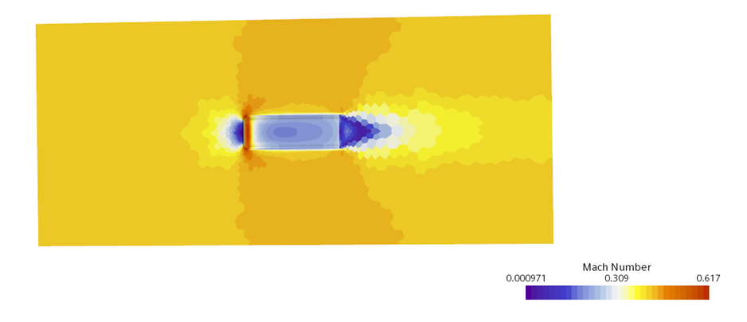

Figure 15: Scalar Scene 1 (Mach Number)

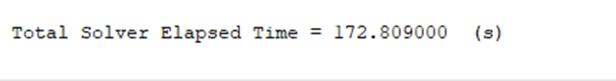

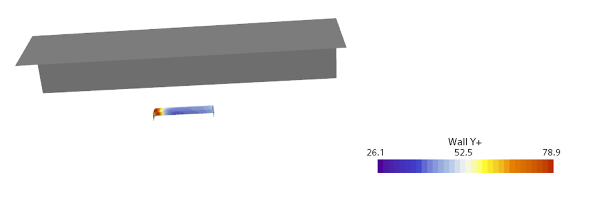

Figure 16: Scalar Scene 2 (Y+)

Figure - Variation with number of prismatic layers

## **4.Parallel Performance**

### Serial processes



### 2 Processes

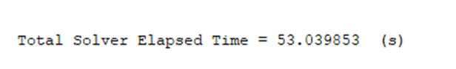

### 4 processes



### 8 Processes

Figure -Acceleration factor vs number of processes

## Mesh base size 0.005m

### Serial

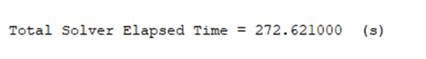

### 2Processes

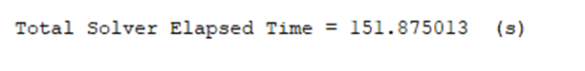

### 4Processes



### 8Processes

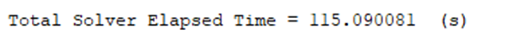

Figure : Acceleration Factor Vs. Number of Processes

**DISCUSSION**

Referring to figures 18 and 19 we can see the acceleration factor vs. the number of processes. We can see that at 4 processes the acceleration factor begins to deviate from perfect scaling. It is also at 4 processes that the acceleration factor reaches a peak. The reason for this is due to the fact that at this number of processes, the computer architecture begins to have trouble speaking between the individual processes. As you increase the processes, the solution should accelerate linearly. However, as the number of processes is increased, instances begin where one process is unable to continue computing until it receives data from the others. As such, inefficiencies in the solution begin, due to the waiting that occurs. This is most likely due to the parallelization algorithms used by the software, but they also might be due how the computer architecture is able to communicate amongst itself.

**CONCLUSION**

This lab presented students with an introduction into using the STAR CCM+ software. It introduced students into how changing a variety of parameters will affect the output of the software. The parameters taken into account include the prismatic layers used to model the boundary layer, as well as the mesh size. This lab also demonstrated how utilizing parallelization will affect the solution. Overall, it is expected that as the number of processes utilized increased, the solution time will decrease. However, due to inefficiencies in the parallelization algorithms in the software, and how the computer architecture communicates, this is not the case. At a certain point the acceleration factor will deviate from perfect scaling, as processes will have to wait for other processes to finish before they are able to continue in the solution. This will result in a lower computational efficiency and can even result in an increase in total solution time.